In the boxes below, record the main focus of each section of the text. Then use this information to identify the main idea.

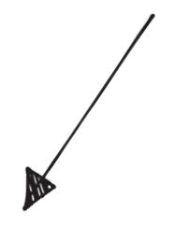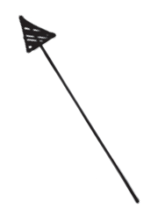

main point - title

main point - paragraph 2

main point - bottom images

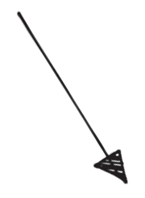

main point - paragraph 1



main point - paragraph 3

main idea of text

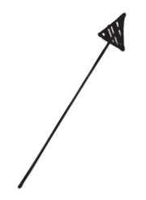

main point - top image

