Task: News Article Analysis

First Fires, Then Floods: Climate Extremes Batter Australia
By Damien Cave
Photographs and Video by Matthew Abbott
Dec. 11, 2021
https://www.nytimes.com/2021/12/11/world/australia/flooding-fire-climate-australia.html
Excerpt One
WEE WAA, Australia — Two years ago, the fields outside Christina Southwell’s family home near the cotton capital of Australia looked like a dusty, brown desert as drought-fueled wildfires burned to the north and south.
Last week, after record-breaking rains, muddy floodwaters surrounded her, along with the stench of rotting crops. She had been trapped for days with just her cat, and still didn’t know when the sludge would recede.
“It seems to take for bloody ever to go away,” she said, watching a boat carry food into the town of Wee Waa. “All it leaves behind is this stink, and it’s just going to get worse.”
Life on the land has always been hard in Australia, but the past few years have delivered one extreme after another, demanding new levels of resilience and pointing to the rising costs of a warming planet. For many Australians, moderate weather — a pleasant summer, a year without a state of emergency — increasingly feels like a luxury.

The Black Summer bush fires of 2019 and 2020 were the worst in Australia’s recorded history. This year, many of the same areas that suffered through those epic blazes endured the wettest, coldest November since at least 1900. Hundreds of people, across several states, have been forced to evacuate. Many more, like Ms. Southwell, are stranded on floodplain islands with no way to leave except by boat or helicopter, possibly until after Christmas.

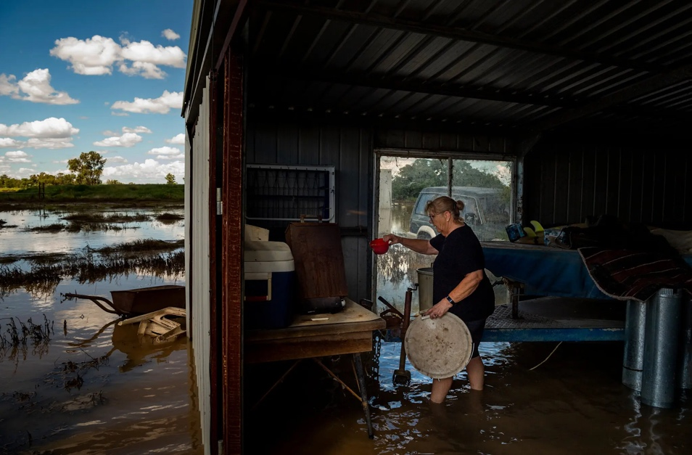 | Christina Southwell in her garden shed in Wee Waa, Australia, where floodwaters have surrounded her house
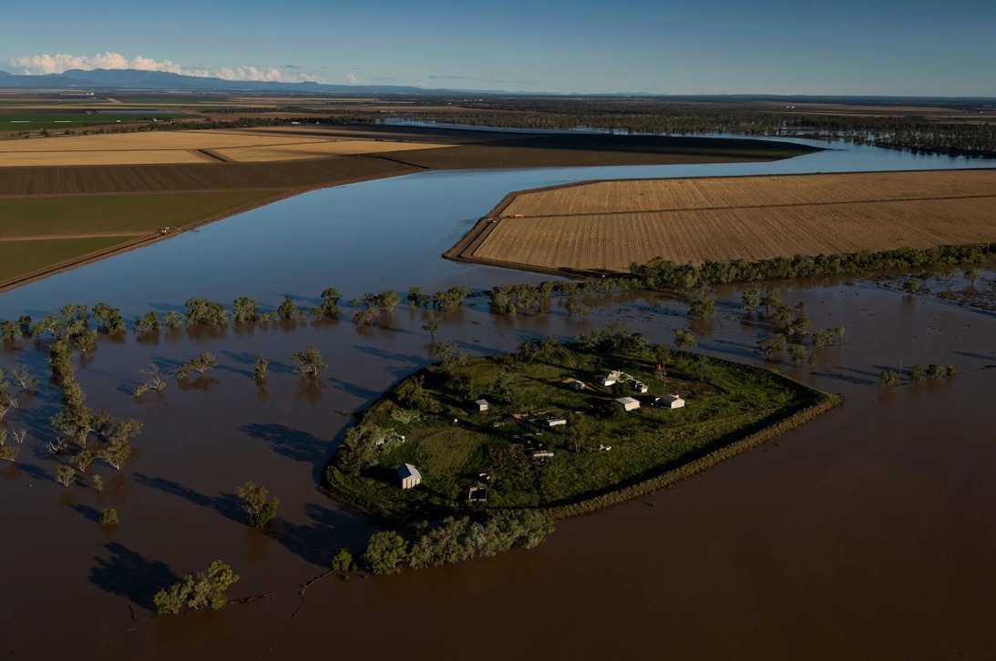 | Hundreds of people, across several states, have been forced to evacuate. Many more are stranded on floodplain islands with no way to leave except by boat or by helicopter.
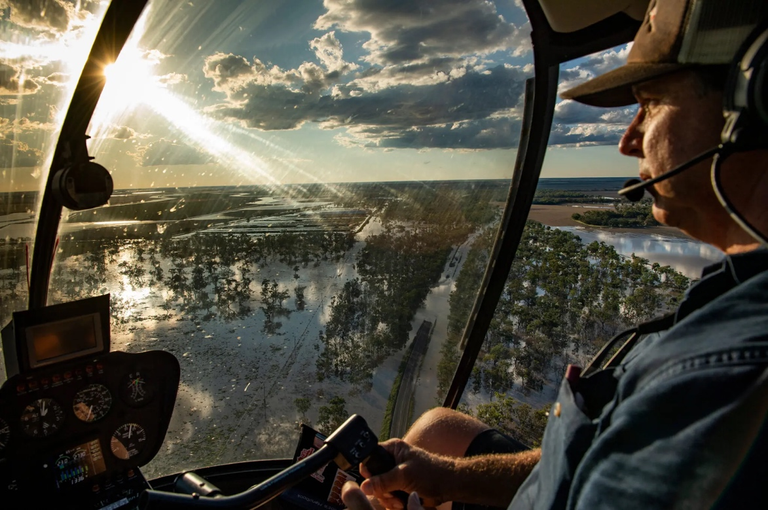 | Bryce Guest, a helicopter pilot in Narrabri, flying over farms in the region.

First Fires, Then Floods: Climate Extremes Batter Australia
By Damien Cave
Photographs and Video by Matthew Abbott
Dec. 11, 2021
https://www.nytimes.com/2021/12/11/world/australia/flooding-fire-climate-australia.html
Excerpt Two
And with a second year of the weather phenomenon known as La Niña in full swing, meteorologists are predicting even more flooding for Australia’s east coast, adding to the stress from the pandemic, not to mention from a recent rural mouse plague of biblical proportions.

“It feels constant,” said Brett Dickinson, 58, a wheat farmer who lives not far from Ms. Southwell in northwest New South Wales, about a six-hour drive from Sydney. “We’re constantly battling all the elements — and the animals too.”

There’s a tendency to think of such extremes as “natural disasters” or “acts of God” that come and go with news reports. But Australia’s nightmares of nature ebb and flow. Its droughts and floods, though weather opposites, are driven by the same forces — some of them timeless, others newer and caused by humans.

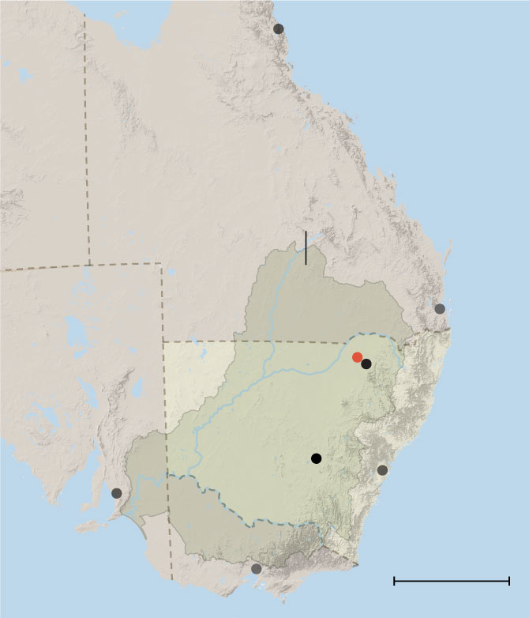
Andy Pitman, director of the ARC Center of Excellence for Climate Extremes at the University of New South Wales, said the ups and downs of weather had been severe for millenniums on the Australian landmass, which is as large as the continental United States and surrounded by powerful climate-driving oceans, from the tropical South Pacific to the colder Southern Ocean off Antarctica.

As a consequence, the El Niño and La Niña patterns tend to hit Australia harder than they do other places, with harsh droughts that end with major floods. Some scientists even suggest that the way marsupials reproduce, with the ability to put active pregnancies on pause, shows that the El Niño-La Niña cycle has been around long enough for flora and fauna to adapt.

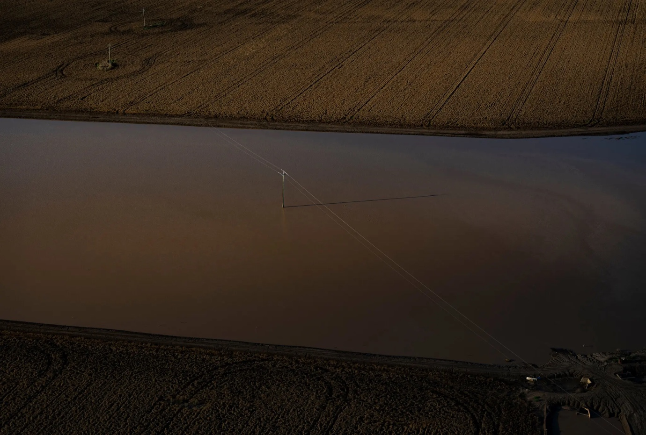
Australia has been hit with harsh droughts that end with major floods, a phenomenon caused by the El Niño and La Niña patterns and intensified by climate change.

On top of that already-intense variability, Professor Pitman said, are now two additional complicating factors: “climate change and human decisions around building things.”
Both make fires and floods more damaging.
“A small change in climate coupled with a small change in landscapes can have a large impact on flood characteristics,” Professor Pitman said.

First Fires, Then Floods: Climate Extremes Batter Australia
By Damien Cave
Photographs and Video by Matthew Abbott
Dec. 11, 2021
https://www.nytimes.com/2021/12/11/world/australia/flooding-fire-climate-australia.html
Excerpt Three
The results are already visible in government budgets. The cost of climate disasters in Australia has more than doubled since the 1970s.
Ron Campbell, the mayor of Narrabri Shire, which includes Wee Waa, said his area was still waiting for government payments to offset damage from past catastrophes. He wondered when governments would stop paying for infrastructure repairs after every emergency.
“The costs are just enormous, not just here but at all the other places in similar circumstances,” he said.

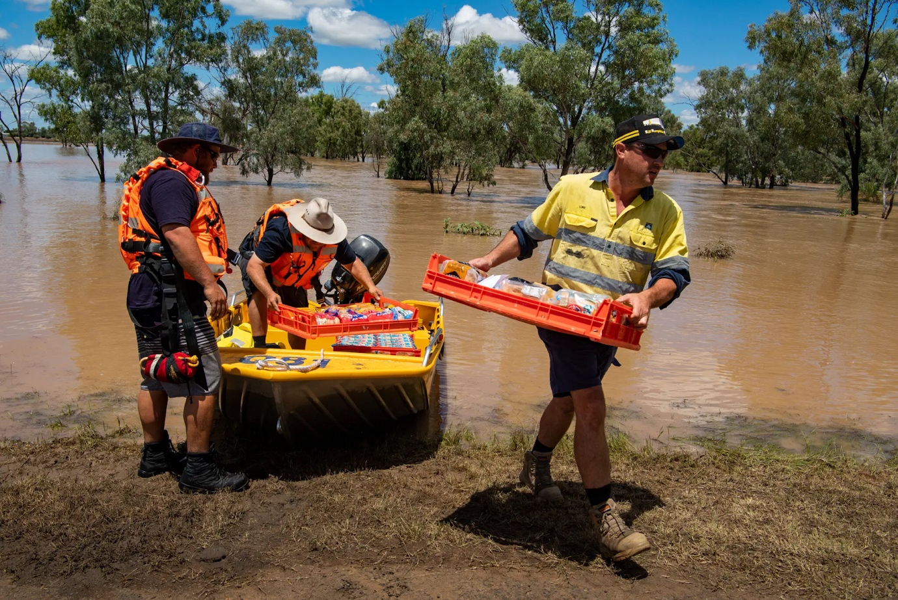
Volunteers and locals transporting food and supplies in Wee Waa.

More viscerally, the impact of a “supercharged climate” is drawn on the land itself. Across the vast tracts of farmland and small towns between Melbourne and Sydney where much of the country’s food, cattle, wine — and coal — are produced, the effects of fire, drought and flood coexist.

Even in areas that did not burst into flames, the heat waves and lack of rainfall that preceded the bush fires killed as much as 60 percent of the trees in some places. Cattle farmers culled so much of their herds during the drought that beef prices have risen more than 50 percent as they rush to restock paddocks nourished (nearly to death) by heavy rain.
Bryce Guest, a helicopter pilot in Narrabri, once watched the dust bowls grow from above. Then came “just a monstrous amount of rain,” he said, and new kind of job: flights to mechanical pumps pushing water from fields to irrigation dams in a last-ditch effort to preserve crops that had been heading for a record harvest.
On one recent flight, he pointed to mountains of stored grain — worth six figures, at least — that were ruined by the rains, with heavy equipment trapped and rusting next to it. Further inland, a home surrounded by levees had become a small island accessible only by boat or copter.
“Australia is all about water — everything revolves around it,” he said. “Where you put your home, your stock. Everything.”

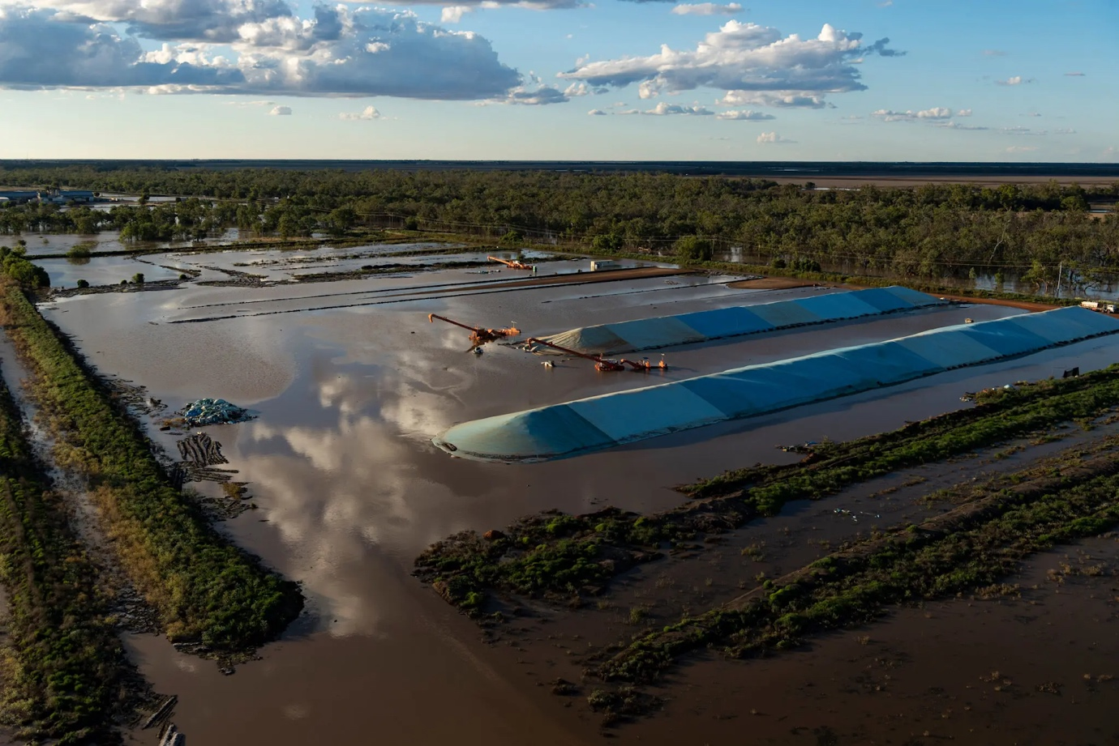
Stacks of stored grain damaged by flooding.

Inside one of Australia’s most disaster-prone towns
Hit by nineteen natural disasters in one decade, the people of this poor, overlooked NSW shire provide a lesson in resilience to us all.
By Fiona Harari
Photographs by Nathan Edwards.
May. 16, 2020
https://www.theaustralian.com.au/weekend-australian-magazine/how-kempsey-nsw-survived-19-natural-disasters-in-one-decade/news-story/1fb43097bd38077ac1436529e7a00897

Excerpt Four

For as long as anyone can remember, flooding has been a regular event on the flatter western side of town. “I lived at South Kempsey and went to Kempsey High School and I don’t know how many times we were isolated and couldn’t get to school,” says long-time SES volunteer Greg Gill, 58. “When you’ve got a river that has a catchment of 11,500km, floods, except in the middle of droughts, are very common here. People are regularly isolated. And the crazy part is that happens before we even get to minor flood height.”
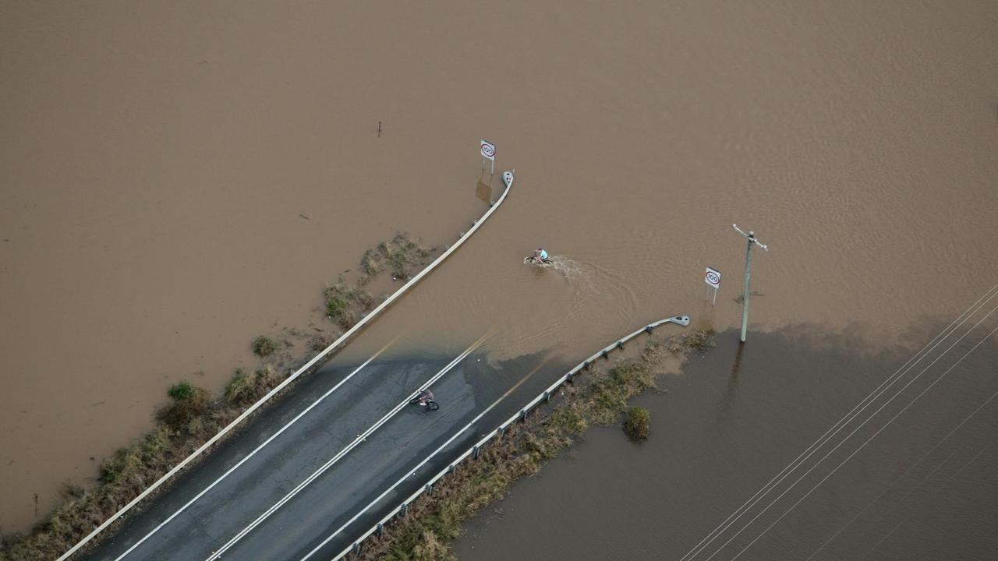

Gill has spent his life in Kempsey and still recalls the 2001 flood that left thousands stranded. Through his volunteer work with the SES he has a detailed list of the dozens of 5m-plus torrents that have stricken the town over its 182 years. The worst, and most notorious, occurred in 1949 when floodwaters reached 8.52m, killing six people and more than 15,000 head of livestock. More than 50 homes and shops were washed away and never rebuilt; decades on, the area where they stood has become a wide expanse of sporting fields.

Arthur Slack was a local councillor during the 1949 flood, which was followed, only months later, by another 8m-plus deluge. “I think it made an impression on him. I know that at home a lot of the talk was about flood mitigation and making sure that didn’t happen again,” says mayor Liz Campbell, Slack’s daughter, who grew up hearing many stories about that terrible time. “He talked about it in relation to how to rebuild the community,” says Campbell. “But in relation to how he felt about the loss and the things that he saw – the great devastation of the houses and people who lost their lives – he didn’t talk about it a lot at all.” In hindsight, she realised her father had been traumatised.

Decades on, Campbell, 67, still lives in her childhood home on the high eastern bank of the river, from where she has a close and protected view of the devastation that too often besets her town. The localised flooding that began in late 2009 set off a decade-long chain of disasters: storms and floods in 2011, a flood and multiple bushfires the following year, then more storms, floods and localised bushfires in 2013. The onslaught resumed in 2016 when multiple natural disasters were declared. And so it has been for many years, with severe fires in 2019 and right up to the arrival of 2020, when almost the entire council area was enduring intense drought.

Then, as the decade turned, coronavirus began its global spread, reaching Australia’s major cities and keeping its distance for a time from regional centres. Still, Kempsey was not immune. While comparatively few cases have been confirmed in the area, its residents have been deemed among the most vulnerable to the pandemic because of their age and general health, according to the Australian National University’s Centre for Social Research and Methods. As the centre’s associate professor Ben Phillips says: “If there were 100 cases in Kempsey and 100 in Bondi, you would expect a lot more trouble in Kempsey.”

It’s a familiar pattern and sometimes it can seem deeply personal. Of the 19 natural disasters declared in Kempsey since November 2009, many were statewide but more than 40 per cent were largely confined to this small coastal strip. And many have occurred under Campbell’s watch. “I’ve seen the effect it has on people and that does take a toll because you take on a little bit of everybody’s story,” she says. “You put on a protective layer [as mayor]. At the end of the day, someone needs to be the person who can’t crumble.”

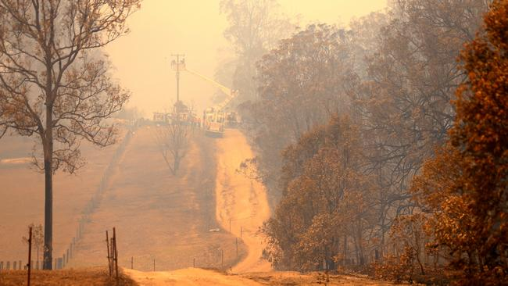
Bushfire at Willawarrin, west of Kempsey. Picture: Nathan Edwards.

Kempsey’s most recent natural disaster began on Friday, November 8. It was Kempsey Cup day and the local racecourse was packed by late morning. Although summer had not yet started, fires had been building upriver and as the first race of the day began, smoke and ash were settling kilometres away over the town. By the end of the second race, Campbell – whose council had only that morning approved a presentation by former NSW fire commissioner Greg Mullins on preparing for fires – decided to leave; soon the entire meet would be halted. “I felt sick in the stomach and I went home,” she says. From the terrace of her beloved weatherboard house, for which she was suddenly acutely aware she had no fire plan, the view normally stretched for kilometres. Now even the river, just metres away, was obscured.

Local man Barry Parsons, 58, had passed by the races and by the time he returned to his home near Willawarrin, 30-odd minutes away, conditions were deteriorating. It was hot, windy and smoky, “like dusk at 2pm”, he wrote on Facebook. Just before 4pm he posted that it was “downright apocalyptic. No bird sounds. Just got winds and mandarin skies”. An hour later: “I haven’t seen a kick of flame yet but this is about as terrifying as it gets without it. Wind has really blown up, smoke and ash filling the sky.” Three minutes later: “Seriously looks and sounds like apocalypse out there. F..ked up being on your own in these times.”

Fire would burn in the region for two months and it would take another deluge of rain in late January to finally extinguish the flames. By then the toll included 67 homes, six bridges and countless outbuildings destroyed, 11 other bridges and kilometres of fencing damaged. And Barry Parsons was dead, his body discovered in burnt-out bush.

For a community more accustomed to the disastrous effects of water, this fire would provide its own challenges. “Getting back to normal life is quicker with a flood,” says Campbell. “The rain comes, the rain stops, the floodwaters subside. The feed goes. The businesses get back to business. And away you go – and your water tanks fill up, so that’s the upside. With fire, there is so much destruction. To grow a tree back takes years. And if it’s compounded by drought, to grow your pastures back takes forever. If your house burns down, getting the funding and doing the physical work takes a very, very long time. You can’t move on.”

There is also the associated fear factor. “Floods can sneak up on you,” says the SES’s Greg Gill. “With fire, everyone is scared of it; with the water, they don’t seem to be so much. People will drive into floodwater thinking they are going to be OK … They wouldn’t drive into a fire, would they? They would drive around and go in the opposite direction if they could get out that way.” By the second weekend in November, when evacuees arrived at a hastily established emergency centre at Kempsey Showgrounds, that fear was obvious. “The trauma in people’s eyes was horrible,” says Campbell. “And I have never seen that in floods. You don’t kind of flee from floodwater, or we haven’t here.”

'Unprecedented' Australian bushfires directly affected one in eight Indigenous people.
Royal commission hears from 15 witnesses on cultural burning at the end of three days of hearings on hazard reduction.

June. 18, 2020
By Calla Wahlquist
Photographs by Brett Hemmings
https://www.theguardian.com/australia-news/2020/jun/18/unprecedented-australian-bushfires-directly-affected-one-in-eight-indigenous-people

Excerpt Five
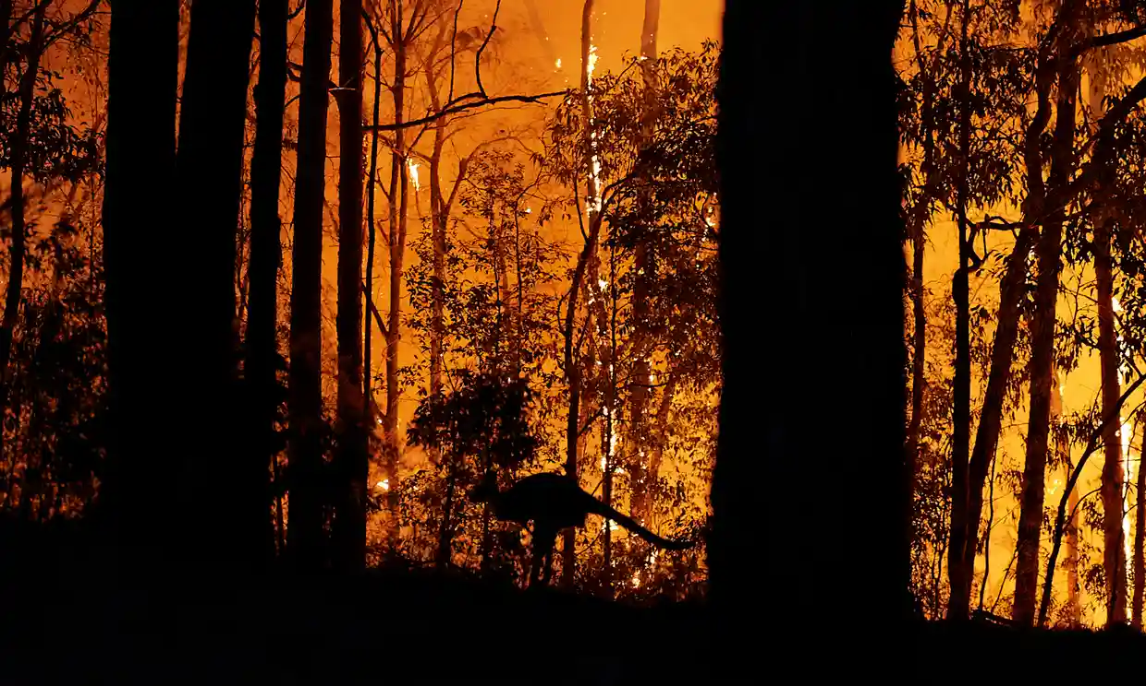

One in eight Aboriginal and Torres Strait Islander people in Australia were directly impacted by the 2019-20 bushfires, the bushfire royal commission has heard.

And according to a study of the geological records of large fires in Australia’s history, the summer bushfires were “unprecedented”.

The royal commission into national natural disaster resilience heard 15 witnesses on cultural burning on Thursday at the end of three days of hearings focused on hazard reduction.

Bhiamie Eckford-Williamson, an Euahlayi man and academic from the Australian National University, told the royal commission that 96,000 Aboriginal and Torres Strait Islander people, including 35,000 children, were affected by the fires that burned in Queensland, New South Wales, the Australian Capital Territory and South Australia this summer.

A pyrocumulonimbus cloud generated by the intense Orroral Valley bushfire south of Canberra, 31 January 2020
Australia had more supersized bushfires creating their own storms last summer than in previous 30 years.
That amounts to 29% of the Indigenous population in affected states, and 12% of the national Indigenous population.

And the Indigenous population in areas hit by bushfires was 4.6%, double the population in the state as a whole, meaning that Indigenous people were “disproportionately affected”.

Despite this, he said, there had been an “extraordinary absence of Aboriginal people” from post-fire inquiries, and a lack of recommendations or policies specifically geared to acknowledging or reducing the impact on Aboriginal people.

Advertisement
“They are often relegated to a historic footnote,” he said.

Eckford-Williamson gave evidence in a panel alongside the University of Wollongong researcher Vanessa Cavanagh, a Bundjalung and Wonnarua woman and former firefighter researching the role of women in cultural burning; associate professor Michael-Shawn Fletcher, a Wiradjuri man and paleo-ecologist from the University of Melbourne; and Dr Timothy Neale from Deakin University.

Eckford-Williamson said that the cool-burn techniques used by Aboriginal people could not be appropriated into western fire management processes, or divorced from the context of other Indigenous land management practices.

“Simply put, if Aboriginal people are not in control of the preparation [and] implementation of burning then it is not cultural burning,” he said.

That is what happens in the NSW national parks and wildlife service, which told the commission that while Aboriginal people undertook low-intensity cultural burning, it also had parks staff who undertook “culturally-informed burning”.

Kija Rangers conduct prescribed burning in the East Kimberley, 2019
Right fire for right future: how cultural burning can protect Australia from catastrophic blazes
Read more
Fletcher said a study of the geological record showed no records of a fire event equivalent to the 2019-20 season, with fires stretching from Queensland to Victoria.

“In that sense these fires are unprecedented in the geological record,” he said.

He said that records from colonial settlers in Victoria showed a “universal shift from an open to a woody or forested landscape following the British invasion and the removal of cultural burning from the landscape”.

He added that while global heating was undoubtedly increasing the fire risk, the landscape now had “demonstrably more fuel in the modern forested region … today than when they were under Indigenous cultural burning”.

All four experts said there should be a national coordinating body that supported and conducted research on behalf of local groups conducting Indigenous land management practices, and that funding for that work, which currently runs on one- to three-year cycles, should be made permanent.

Scott Falconer from the Victorian Department of Environment, Land, Water and Planning told the inquiry that until the cultural burns program began in 2017 there had not been any cultural burning on the landscape for at least 150 years. Since then, 20 burns have been conducted, and more than 100 have been identified by the six traditional owner groups involved in burning in Australia.

NSW also did not conduct any authorised cultural burning on public land until 2017, Queensland started supporting the practice in 2007, and the NT has been supporting it since 1981, when the joint management of national parks first began.

