The Land Where I Live - Flora and Fauna Explorations - Science - Years 5 & 6
|Teacher Information
Understanding Custodianship from an Aboriginal perspective:
In this article in The Conversation, Aunty Munya Andrews explains that, “Many Indigenous peoples the world over generally do not believe that anyone or anything can be ‘owned’, especially the land.” Rather than ‘owning’ the land, she says, "we believe that we belong to the land, in which there is no concept of individual ownership but rather one of joint belonging, collaboration and care of the land." For more learning about connection to Country, explore Culture is Life's Back to Nature resources here.
Tip: You could direct students to this blog that responds further to The Conversation article on the Evolves website (https://www.evolves.com.au/land-ownership-and-reconciliation).
Understanding what ‘Country’ means for Aboriginal people:
"When Aboriginal people use the English word 'Country' it is meant in a special way. For Aboriginal people; culture, nature and land are all linked. Aboriginal communities have a cultural connection to the land, which is based on each community's distinct culture, traditions and laws. Country takes in everything within the landscape - landforms, waters, air, trees, rocks, plants, animals, foods, medicines, minerals, stories and special places. Community connections include cultural practices, knowledge, songs, stories and art, as well as all people: past, present and future. People have custodial responsibilities to care for their Country, to ensure that it continues in proper order and provides physical sustenance and spiritual nourishment. These custodial relationships may determine who can speak for a particular Country." Quote source: http://www.visitmungo.com.au/aboriginal-country.
About Classification: Classification is the process of grouping a variety of plants or animals according to similarities. This process simplifies studying them. A simple type of classification system is the dichotomous key. At every branch, there are two choices. Based on observations of the items being studied the classifier makes their best decision and follows a path down the key. Eventually, there are no more choices to be made and the object is ‘grouped’ or classified and can be given a name. For more information on classification visit and show your students the following Animal Classification | Evolution | Biology | FuseSchool video: (www.youtube.com/watch?v=L6anmd7DnYw).
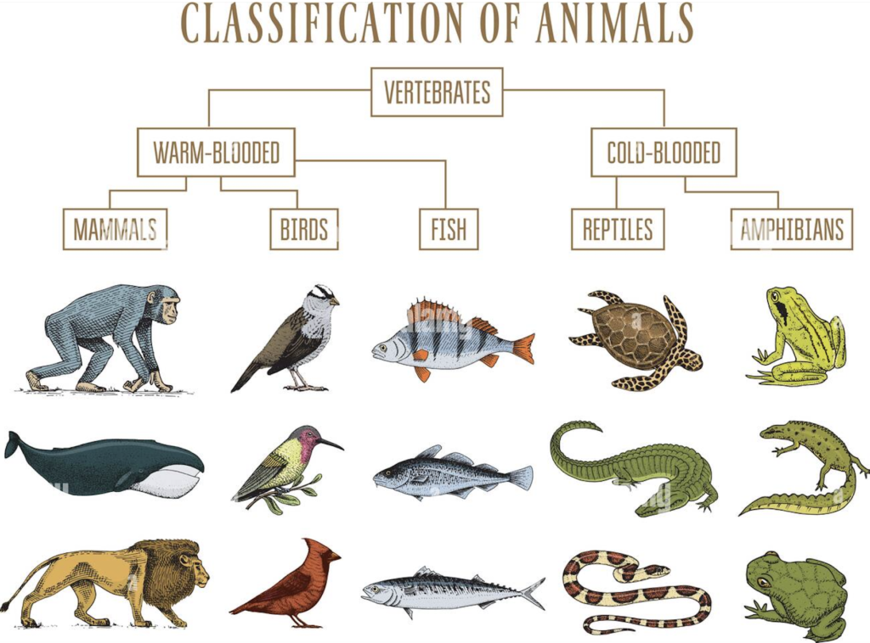
Image Source: Image ID MTEW26 www.alamy.com.
About recording data on a spreadsheet: Citizen science activities can be very valuable and powerful. It utilises individuals who collect data and information and record it in a centralised databank such as a shared google spreadsheet. Students will feel quite empowered and part of a collective when they collect data and add the information to the shared spreadsheet.
Leaf dichotomous key: Here is an example of questions you may need to consider when creating a Leaves classification dichotomous key. Keep in mind that students are not required to identify the leaves. Instead, we are asking students to develop their scientific process skills. This task is about making observations and decisions. Students will develop a greater appreciation of classification by observing and carrying out following questions:
- Do they have a serrated edge?
- Do they have protruding veins?
- Are they skinny?
- Are they furry?
- Do they smell like lemon?
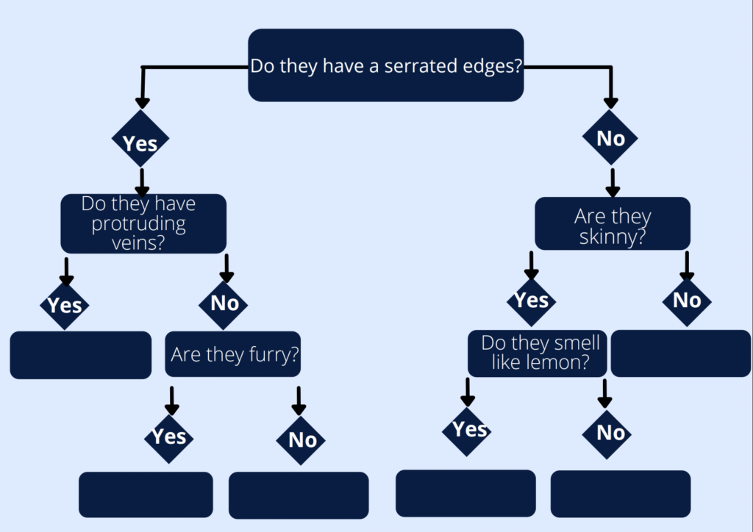
Recording data in a table: In part D of this lesson, students will be asked to observe animals and then create a table. Designing tables to collect data is actually quite a challenging scientific skill. Discuss with the class what might be important to include in the table. Here is an example of some questions you can provide your students with:
Animal | A tally of times this species of animal was spotted | Brief description of the animal | Habitat (Where does the animal generally live)
Hot tips:
1. Students love going outside into the playground (especially during class time)
2. Students enjoy any excuse to use their phones — they love taking photos of animals and sharing them with their friends
3. Students will feel empowered as they upload science data into a shared document.
About Regeneration:
Sustainability seeks to reduce harm whereas regeneration takes things a big step further. Regenerative design and development reverses environmental degradation and social fracturing; it addresses the unprecedented challenges our environment faces today by enabling human systems to co-evolve with nature. If our intention for this planet is sustainability, then regeneration is the active and inclusive process that can get us there. Regeneration is the default mode of life - from the cells in our bodies to a forest after fire.
Learn more about regeneration here (https://theregenerators.co/what-is-regeneration/) and share the "What is Regeneration" video: https://vimeo.com/693818604 and use password: EDU_RA to access the link. The video will help inspire your class' thinking and refresh their understanding of regeneration.
A good frame of reference for the damage we are doing is the Planetary Boundaries framework by the Stockholm Resilience Centre: (resilience.org/research/planetary-boundaries). The work of Kate Raworth and Doughnut Economics also highlights these breached ecological boundaries plus incorporates the breached social boundaries: (doughnuteconomics.org/about-doughnut-economics). This video (https://youtu.be/axKHLjTm4rY) presented by director Damon Gameau will help provide context to students about where we are with our Planetary Boundaries and why we need to regenerate before we can achieve sustainability.
Film Synopsis:
Regenerating Australia is a short film by the writers and producers of the award-winning 2040 film. It is based on a 4 month interview process with a diverse group of Australians who shared their hopes and dreams for the country’s future.
Set on New Year's Eve of December 2029, a news anchor is ending the nightly bulletin with a look back at the decade 'that could be’. A decade that saw Australia transition to a fairer, cleaner, more community-focused economy. The film is a construction of news reports and press conferences featuring real journalists, politicians, business leaders and citizens.
The film brings to life the greener, more vibrant cities and communities that the interviewees are asking for. We see what a high-speed rail network connecting regional areas and cities would look like, what large scale wind, solar, battery and hydrogen projects would do for hundreds of thousands of employees, and show the impacts of landscapes coming to life when regenerative agriculture and reforestation programs combine with Indigenous knowledge and fire ecology to bring more people back onto the land.
This ‘mocked up’ look back at this critical decade is full of hope and aspiration, mapping out a pathway for change that can lead us to a more sustainable future. But it is a muscular hope, as each news event is grounded in the research and modelling of several organisations that have been examining and advocating for such a transition.
The main solutions highlighted in the film are:
- Valuing, amplifying and adhering to First Nations knowledge
- Decentralised decision-making with more community involvement
- Regional investment that creates local jobs and economic activity
- Community-led clean energy projects and localised food systems
- Regenerative farming and land management practices.
How to access the Regenerating Australia film:
Regenerating Australia will be launching in March with a national tour of Q&A events with Director Damon Gameau and special guests. Find session times and cinema locations here. Australian schools can apply for a free educational license to screen the film either virtually or on the school campus. Schools will receive a digital copy of the film and are also invited to download the free School Action Toolkit. Bookings can be made here with screenings commencing in April. The film is also available on ClickView.
To view the trailer click here.
Regenerating Australia is a Regen Studios film developed and produced in association with WWF-Australia. Cool Australia and Regen Studios would like to acknowledge the generous contributions of Shark Island Foundation, Culture is Life, Documentary Australia Foundation, and our philanthropic partners in the development of these teaching resources.

